Alex Fergestad

For finding the source code, you have to go to this website: https://opensource.samsung.com/ then highlight release center and then click TV. Go to the second page and then one of those rows should have the tv listed. I downloaded the source zip file which is pretty big which I thought all that mattered.

Screenshot for reference:
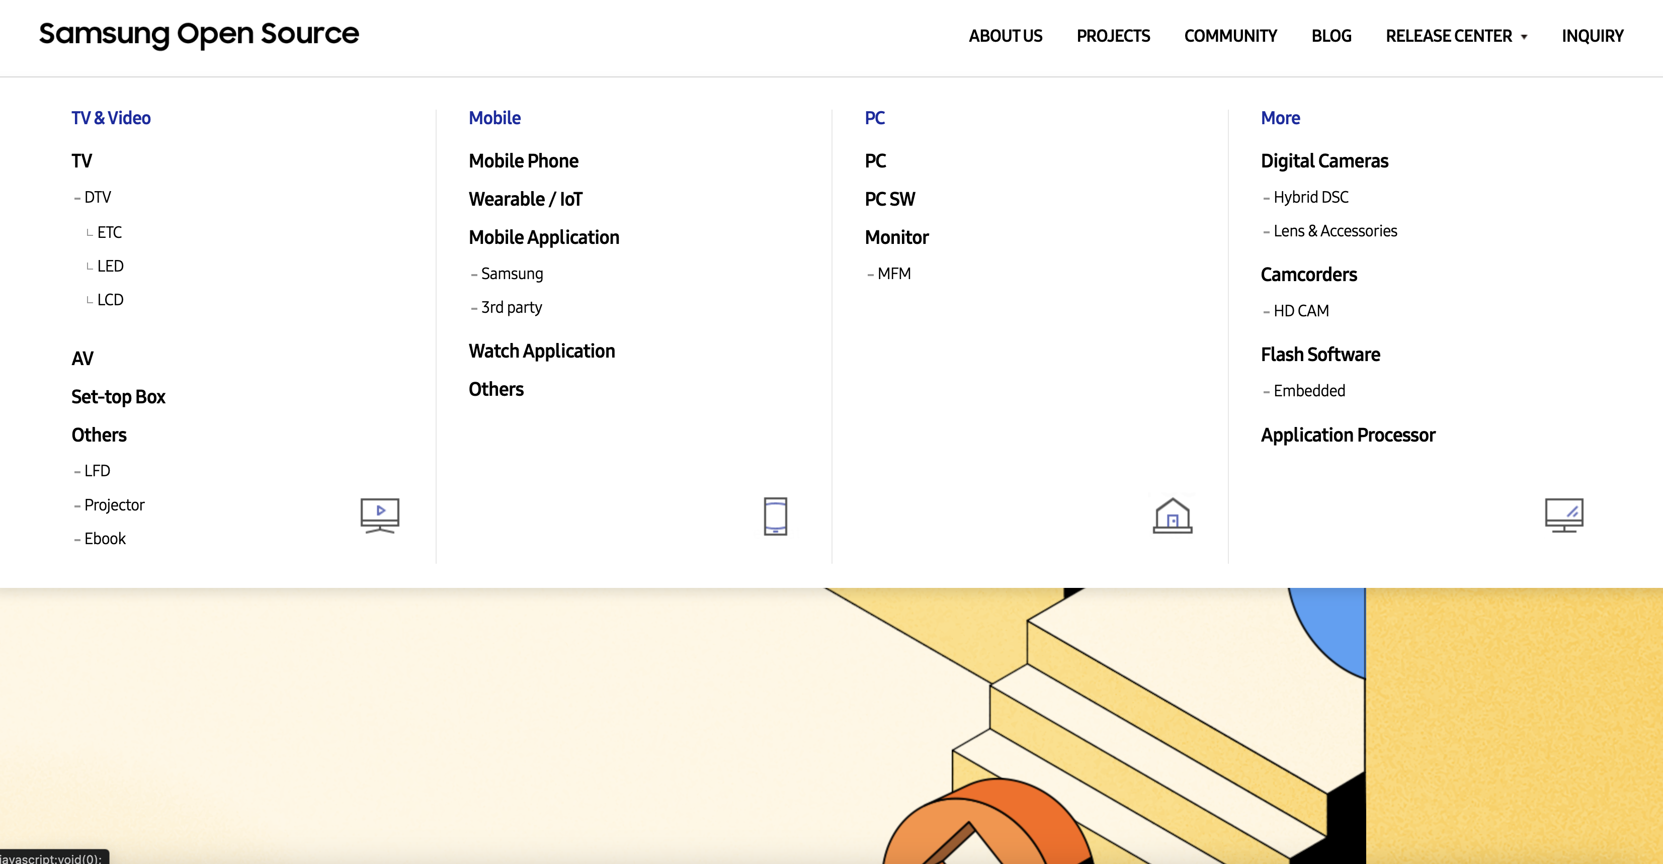

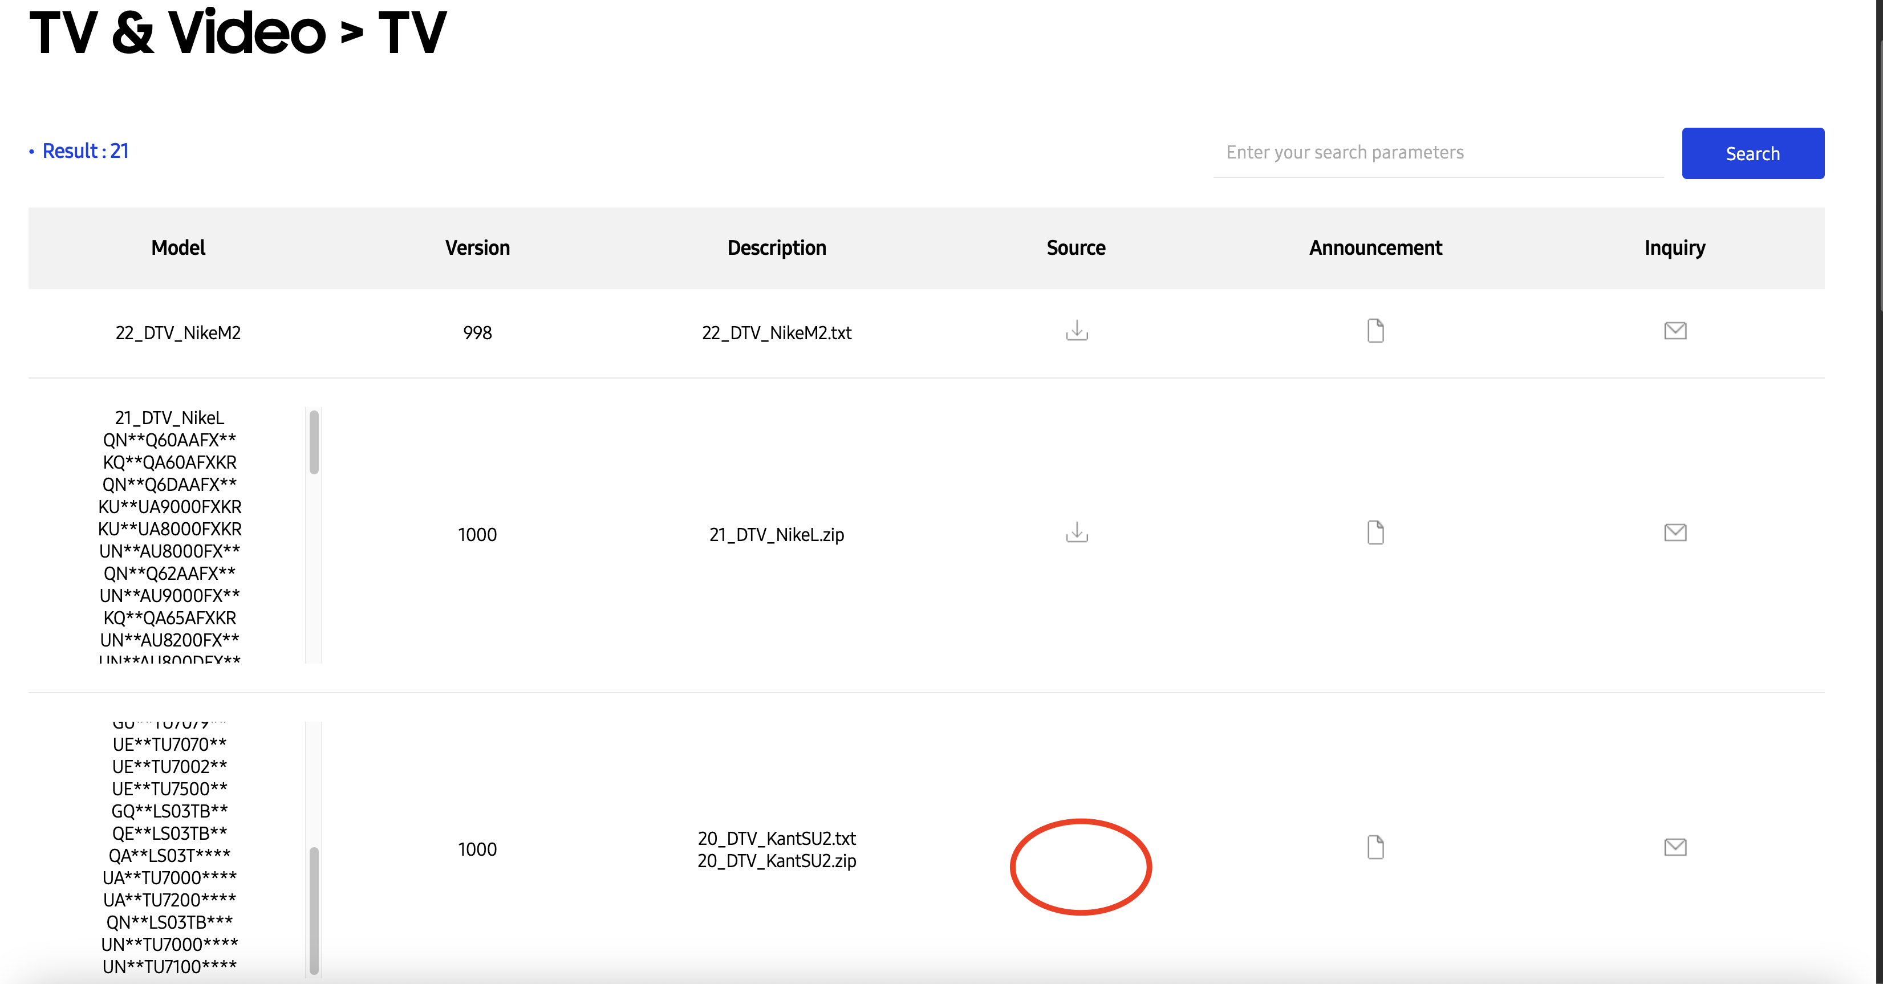

After downloading the 20_DTV_KantSU2.zip file, I opened up the zip code in an ide editor, vs code, and did not get far after. There is no README files present in the zip, just text files with gibberish. There are some files that I think can run but there is no documentation on showing where to start. If you truly wanted to run this program, you will probably have to contact someone in the Samsung software developer community.

